Long Lead Test?

If “Long Lead Test?” Appears on the PB500 screen, the resistance reading is greater than expected for a standard-length lead.
Wait up to 10 seconds for the testing sequence to finish.
Use the following table to calculate the whether the resistance reading is acceptable.

Cable CSA | Ohms per metre
0.5mm² | 0.039Ω
0.75mm² | 0.026 Ω
1.0mm² | 0.0195 Ω
1.25mm² | 0.0156 Ω
1.5mm² | 0.0133 Ω
2.5mm² | 0.008 Ω
4.00mm² | 0.005 Ω

The above table shows the ohms (Ω) per metre value for the CSA (cross sectional area) of the lead.

The maximum figure is calculated by multiplying the length of the lead in metres by the Ohms per meter value for the lead’s CSA plus 0.1 ohm. The CSA is stamped on the lead, e.g., a lead of 25m with a CSA of 0.75mm2 is calculated as follows:

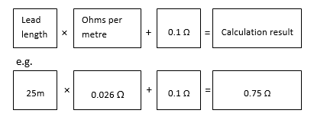

Retest and when “long lead test?” appears, press the Cord button again. The result will now show as a Pass.

